
Prof. Austin Tate, I4IS Senior Researcher, 1-Jan-2014
Look Up – Look Out – Reach Out
As a child growing up with Eagle comic’s Dan Dare, E.C. Eliott’s Kemlo books and TV programmes like Gerry Anderson’s Fireball XL5… watching the first human spaceflights in my teens and following the Apollo landings while at University looking "up and out" has always been a part of my life. I look up at the Moon as I walk home... so close that we can get there in similar time to reaching a remote holiday destination on Earth. I look at the bright objects that often hang in our evening sky and think of what is happening now as our early explorers like Galileo and Cassini continue their dance round the gas giants. I am thrilled that the Voyagers continue their mission as they enter interstellar space.
My computing, science and engineering career has been blessed by involvement with space scientists and spacecraft engineers in the UK, Europe and the USA with our artificial intelligence planning and autonomy systems put to use for planning Earth-orbiting and the deep space missions. But I am equally excited that our names and artifacts are carried on missions through the tail of a comet from the outer reaches of our Solar System, to Mars and to the surface of Titan.
The technical challenges of sending a spaceship to another star is a fantastic opportunity to consider the very many challenges that must be faced with long lived autonomous, repairable and sustainable vehicles which can offer many insights relevant to our own environmental, medical, engineering and other issues. It offers a “grand challenge” that can stretch our own vision and systems.
Mars, Titan and Europa are fascinating and we will learn much as we explore with our remote sensing instruments, our robots and eventually ourselves travelling in our local area. But there are many points in our night sky beyond those few we can almost reach out and touch… and those take a leap of imagination, science and engineering as well as vision to reach out to. The Voyager disc is a great example of this sort of vision of folks like Carl Sagan and other visionaries - seeing beyond our local area and looking beyond the short term.
So look up, look out and reach out as we work towards seeing that starship depart and overtake Voyager as it takes us on our next journey of discovery.
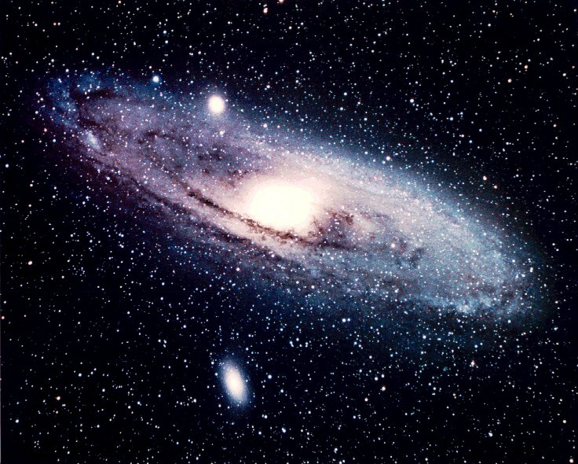
Full address for posts from distant parts of the Universe…
Prof. Austin Tate
Artificial intelligence Applications Institute
Room IF2.14
Informatics Forum
11, Crichton Street
Edinburgh EH8 9AB
Scotland
United Kingdom
Europe
Earth
Solar System
Orion Arm
Milky Way Galaxy
Virgo Supercluster
The Universe

